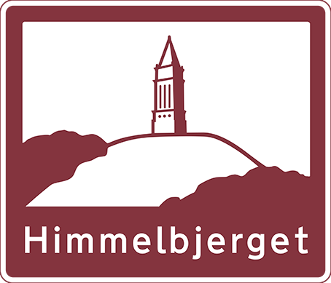
- Grants are up to $500 for registration cost for Himmelbjerget Danish Camp in Corbett, Oregon. Note that funds are sent directly to NWDA, and you will receive a refund from NWDA after camp has concluded
- Submission deadline is May 15th, 2022
- Mail, or email, this application form and a 100-word typed essay on your Danish connection, or What is so great about Denmark (Parents: Helping with typing is fine, but please allow your children to use their own words)

Mail to: Email to:
Mt. Hood Lodge# 81 Lodge81DSS@gmail.com
16116 SW Deline Ct.
Beaverton, OR 97007
Name of Camper:__________________________________________ Birth date:_________________

Address:____________________________________________________________________________
City:__________________________________________ State:___________ Zip:__________________
Phone#:____________________________ Email:___________________________________________
Are you, your parents, your grandparents or great-grandparents members of Danish Sisterhood, Mt. Hood Lodge #81 Yes No
Have you attended Himmelbjerget Danish Camp before? Yes No
If yes, how many years _________
Cost of camp _____________________________________
Are you applying for any other grants from other organizations towards Himmelbjerget Danish Camp this year? Yes No
If yes, please list organizations____________________________________________________________
I am the parent/guardian of the minor child who is applying for a Himmelbjerget Camp Grant and agree that Danish Sisterhood of America will not be held responsible for any accidents or other occurrences to or from the camp, or while in attendance if a grant is awarded.
Submission deadline is:
May 15th , 2022
___________________________________________________
Parent/Guardian's Signature Date

