Johannes V. Jensen, The Fall of the King, 1900-01.
Dear book club friends,
For the month of February, we are reading the classic The Fall of the King (Kongens Fald) by Johannes V. Jensen. He won the Nobel Prize for Literature in 1944, and this book was chosen as the best Danish book of the 20th century:
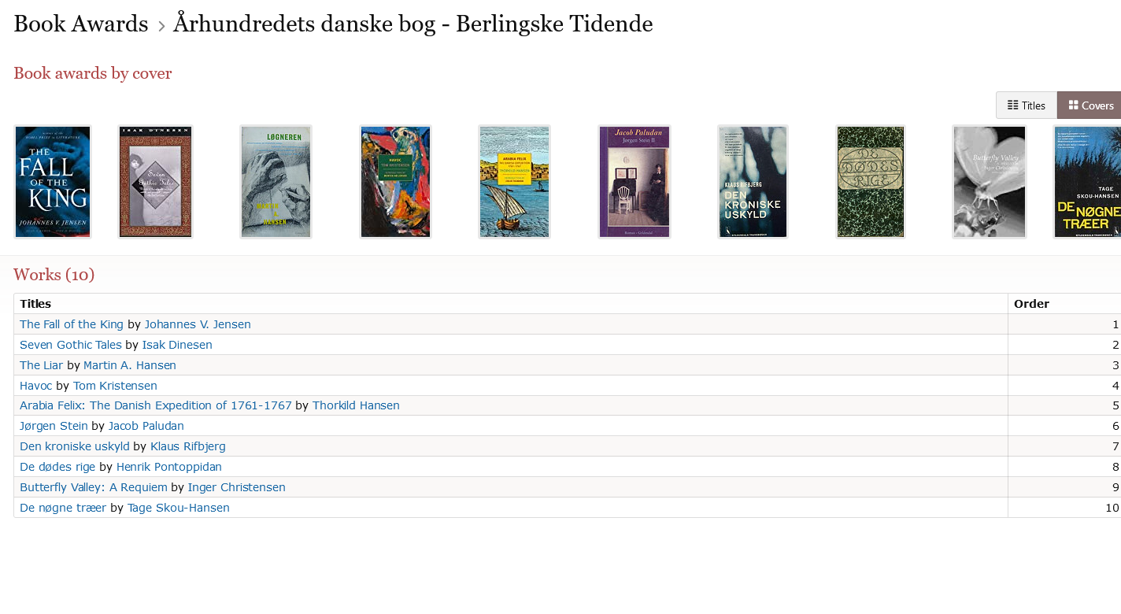
Many of you have requested this book as this year’s classic, so I am pleased it has been translated and made available for a larger audience.
The author builds his book around factual and presumably invented historical events in Denmark from 1497-1535 + (there is no exact year for the end of the book, but King Christian 2 dies in 1559, so it is assumed to have ended around 1550).
The book is divided into three sections: The Death of Spring, The Great Summer, and Winter. Each section is again divided into sub-sections, so the author embraces many sub-themes along the way. This does not necessarily make it an easy read as the topics are philosophical and written in an incredibly descriptive, metaphorical language with ubiquitous lyricism permeating the text. Nonetheless, I hope you will sit back cozily and enjoy this masterpiece in Danish literature.
I am going to prepare a power point that will cover the important historical events of the time. In trying to provide a background with both history and culture, I hope the profundity and multi-faceted themes of the book become more accessible.
At times, the translation, to me, does not convey the true sense of the words. For that reason, I have added the literal translation from Danish when I thought it was important for the nuances.
The Death of Spring, 1497-1500
- What are your first impressions of the book: the style, vocabulary, description of characters, scenarios, nature, etc.?
- What does it mean to have to get into the city before the ports are closed?
- What is Mikkel’s problem? Why does he beg? Why: “Mikkel Thøgersen set out for home. He was tired of living, for this day at least” (Kindle p.20) – Literal translation from the Danish: “he was tired of living any more that day”?
- What is life and living like for Mikkel?
- What is/are the reason(s) for Mikkel’s depression?
- How do you interpret Mikkel’s nightly experience in the churchyard – what is he doing and why?
- Why does Otte Iversen “fall,” and of what does his fall consist?
- How is the treatment of Susanna compared to the words about “not here, not hanged” (Kindle p. 41) Literal translation from the Danish: “The one who is gone is not hanged.”
- What is the effect of Susanna’s treatment on Mikkel and why?
- Why is Mikkel interested in Ane Mette?
- Discuss the notion of living with fear and needing to live with fear (“It was as if he could not live without dread.” (Kindle p. 55).
- What happens with Mikkel and Ane Mette and why? How do you feel about Mikkel now? And about Otte when he returns?
- What is the conclusion of the first part?

The Grand Summer, 1520-23
- In what capacity do we meet Mikkel now, and how is he?
- Who is Axel, and what is his story?
- What has happened to Mikkel during his 20 years away from home
- How does the author create suspense and expectation, a movement forward, and the climax?
- What is the focus of the description leading to the bloodbath, and what is the role of the King? How does the author deal with history?
- There are many dreams in the book. What is their role, and what do they signify?
- How does Axel perceive the bloodbath and the King’s power?
- What does Lucie (who steals Axel’s treasure map) represent?
- What does the author say about loneliness and life, death, and religion?
- Why doesn’t Mikkel die, and does Axel know about the theft of the paper?
- What is the significance of Mikkel’s time in the church as well as all the bells tolling?
- What is Axel’s problem? (Sigrid – Kirsten – Magdalene).
- How is Axel’s destiny connected to that of the King?
- Why must Axel die? What does he symbolize? “This is the great Land of Summer, the Land of Death” (Kindle p. 150)
- What does the author mean with the sentence about the King’s power falling because he used it? “Yes, the King’s power came to an end even as he used it” (Kindle p. 151) Literal translation from Danish: “Yes, as the King’s power came to an end as he used it.” “He who will rake must learn to take.” (Kindle p. 151). Literal translation from the Danish: “He who strikes, gets.”
- What is the conclusion for the King and why?
- What is the moral of Axel’s treasure?

Winter
- Looking back at the first two sections, think of the way the author uses language as if it is a paintbrush. What pictures do you see in your mind? (e.g. his descriptions of landscapes, nature etc.)
- What has changed in Mikkel and his native place?
- How does Mikkel feel when he sits next to the bodies of Otte and Steffen and philosophizes about time?
- Why did the peasants lose their rebellion?
- How is time described?
- Discuss the description of human nature in the sub-section “Time” and with Jens Andersen.
- Discuss the theme of vacillation (translated as fickleness).
- The author closes the circle with Susanna in her old age as she ends with the King’s end. How do you perceive this in the bigger picture painted by the book?
- Comment on the extended use of analogies and metaphors in the book.
- The question about the sun and the earth is heresy. How does Zacharias intend to solve it?
- What is the purpose of including Carolus (the homunculus)?
- Discuss “The one who does not die every day will never live” (Kindle p. 216).
- Discuss “The long capricious nose was completely white” (Kindle p. 223). Literal translation from the Danish: “Mikkel’s long vacillating nose was completely white.” Cf. question 7.
- What is the meaning of Jakob’s demise – what ails him, and why does he commit suicide?

